PROFILE
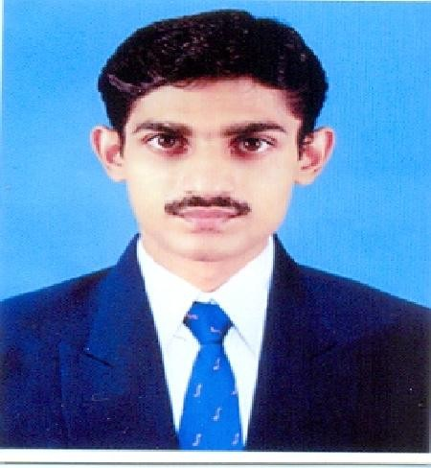
- Name : K Anwar Sathik

- Sex : Male

- Designation : Assistant Professor
4. Date of Birth : 01-05-1984

Address :

Residential Office
20 Sultan Street, Department of Computer Science & IT (SF)
Keeranur – 622 502, Jamal Mohamed College (Autonomous)
Pudukkottai – District. Tiruchirappalli– 620 020.
Mobile: 99651 87007 E-Mail: anwarsathikk_1584@Yahoo.co.in

Educational Qualifications:

Examination Passed Year B C A - 2004
M C A - 2007
M.Phil (C.S) - 2012

Experience:

Polytechnic: 1 Year
Undergraduate: 12 years
Postgraduate: ---
M.Phil: ---
- Languages known : English, Tamil.

- Areas of Specialization : 1. Programming in C,
  - Object Oriented Programming with C++.
  - Visual Basic 6.0

Subjects Taught :

Under Graduate : 1. Office Automation
  - Programming in C

  - Object Oriented Programming with C++,
  - Java Programming,
  - Web Technology,
  - Visual Basic,
  - Basic Concept of computer science
  - Desk Top Publishing
  - Internet and its Applications
  - E-commerce
Post Graduate : -------

  - Details of Seminars / Conferences / Workshops Attended:

• Two Days Workshop on “Research Methodology in Computer Science” at PG & Research Department of Computer Science, Jamal Mohamed College (Autonomous), Trichy - 20, from December 21st to 22nd of 2010.
• UGC Autonomous Grant National Level Seminar On Examination Reforms organized by PG & Research Department of Computer Science, Jamal Mohamed College (Autonomous), Trichy - 20, on February 24, 2012.
• UGC Autonomous Grant National Conference On Advanced Computing organized by PG & Research Department of Computer Science, Jamal Mohamed College (Autonomous), Trichy - 20, on 7th March, 2013.
• State Level Seminar On Computing And Communication Technologies organized by PG & Research Department of Computer Science, Jamal Mohamed College (Autonomous), Trichy - 20, on 25th February 2015.
• UGC Autonomous Grant National Conference On ADVANCED COMPUTING organized by PG & Research Department of Computer Science, Jamal Mohamed College (Autonomous), Trichy - 20, on 5th March, 2015.

